COLLEGE NAME:JP COLLEGE OF ENGINEERING
COLLEGE CODE:9512
PROJECT NAME: SMART WATER MANAGEMENT
PROJECT ID:Proj_211932_Team_1
TEAMS NUMBERS:
- M.SAMYDURAI,951221106040
Email:samydurai2004@gmail.com
- S.SUNDARAN, 951221106304
Email:sundaranvkp25@gamil.com
- M.KALAISEVAN,951221106016
Email:junga4736@gmail.com

SMART WATER MANAGEMENT SYSTEM:
DESIGN IDEAS:
Designing a smart water management project involves integrating technology to monitor, control, and optimize water usage. Consider implementing sensor networks for real-time data collection on water quality and consumption. Use analytics to identify patterns and anomalies, enabling efficient resource allocation. Implement automated control systems for valves and pumps based on data insights. Ensure cybersecurity measures to protect the infrastructure. Additionally, incorporate user-friendly interfaces for stakeholders to access and understand the data, promoting awareness and responsible water usage.
CONCLUSION
A Smart water management system is imperative for addressing the growing challenges of water scarcity and ensuring sustainable use of this precious resource. By leveraging advanced technologies such as sensor networks, data analytics, and automated control systems, we can achieve real-time monitoring, efficient allocation, and informed decision-making in water management. This not only enhances resource optimization but also contributes to environmental conservation. The integration of user-friendly interfaces fosters community engagement, raising awareness and promoting responsible water consumption. As we navigate a future with increasing water demands, smart water management stands as a crucial tool in securing a resilient and sustainable water supply for generations to come.
STEPS FOR THE FLOW CHART:
- Start:
  - Begin with the start symbol.
- Sensor Data Acquisition:
  - Use a process box to represent the step of collecting data from water sensors.
  - Connect this to a decision diamond to check if the sensor data is valid.
- Valid Data?
  - If yes, proceed to the next step.
  - If no, loop back to the data acquisition step.
- Data Processing:
  - Another process box for processing the acquired data.
  - Connect to a decision diamond to check if there are anomalies or thresholds are crossed.
- Anomalies or Thresholds Crossed?
  - If yes, trigger an alert process (send notification or alarm).
  - If no, proceed to the next step.
- Control Decision:
  - Decision diamond to determine if any control action is required.
  - If yes, move to the control process.
- Control Process:
  - Process box for implementing control actions (e.g., closing a valve).
- Data Logging:
  - Process box for logging data to a database for future analysis.
- Communication:
  - Process box for communicating relevant information to the user or central system.
- End:
- End symbol to conclude the flow chart
FLOW CHART:

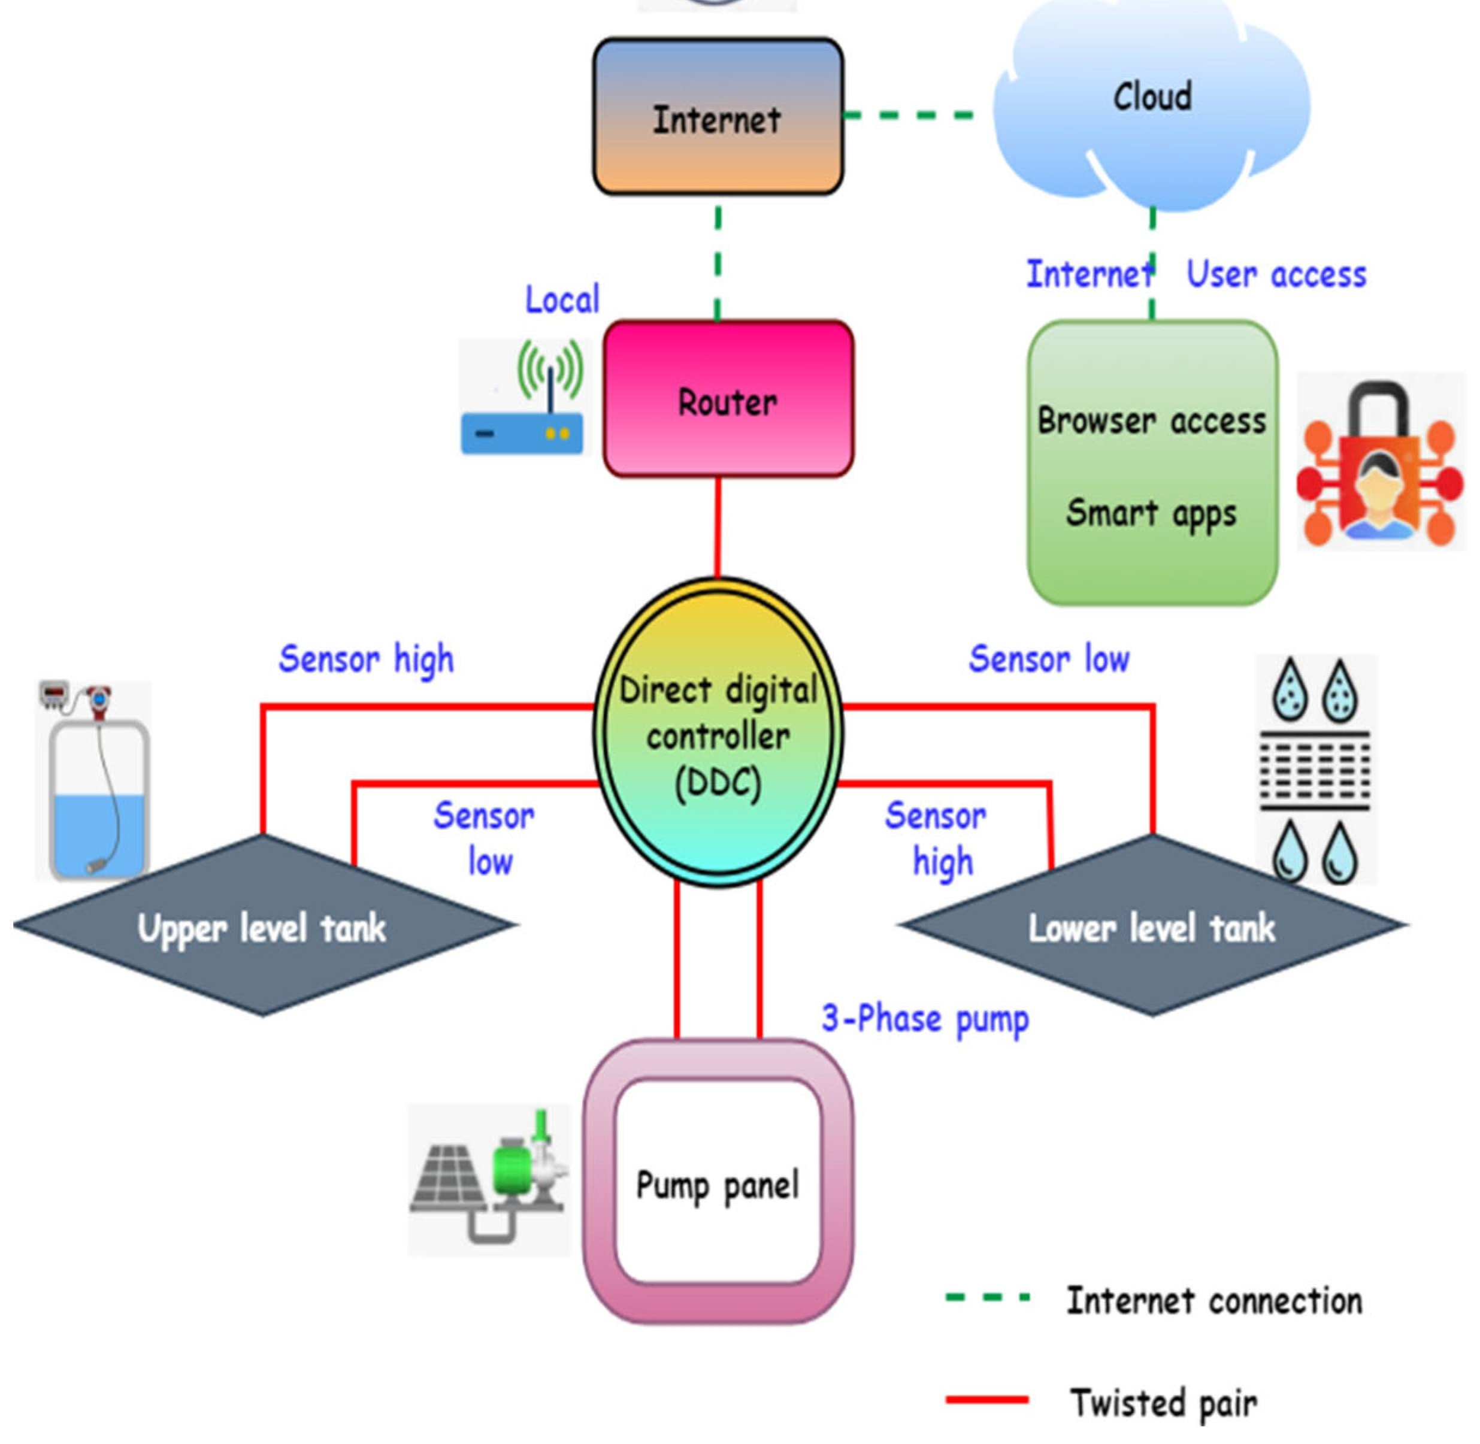

BLOCK DIAGRAM:
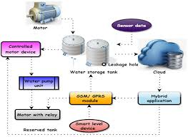
BLOCK DIAGRAM DESCRIPTION:
A smart water management system based on the Internet of Things (IoT) typically involves various components.
- Water Sensors:
  - These sensors are deployed in key locations, such as reservoirs, pipelines, and distribution points.
  - They monitor water quality, quantity, and potential issues like leaks.
- Microcontrollers:
  - Connected to the water sensors, microcontrollers process and transmit data.
  - They might use platforms like Arduino or Raspberry Pi.
- Communication Module:
  - Facilitates the transfer of sensor data to the central control system.
  - Common communication protocols include Wi-Fi, LoRa, or cellular networks.
- Gateway:
  - Aggregates data from multiple microcontrollers and manages communication.
  - Acts as a bridge between the local network and the wider internet.
- Cloud Platform:
  - Receives, stores, and processes data from the gateways.
  - Allows for remote access, analysis, and control of the water management system.
- Data Storage:
  - Long-term storage of historical data for analysis and trend identification.
- Data Analytics:
  - Utilizes machine learning algorithms or statistical methods to derive insights from the collected data.
  - Identifies patterns, anomalies, and potential issues.
- User Interface:
  - A dashboard or user interface accessible through web or mobile applications.
  - Provides real-time information, historical trends, and control options for users.
- Control System:
  - Enables automated control actions based on analyzed data.
  - For example, adjusting water flow, detecting and isolating leaks, or activating alarms.
- Actuators:
  - Devices that execute control commands, such as valves, pumps, or alarms.
  - Connected to the control system to implement necessary actions.
- Security Measures:
  - Encryption and authentication protocols to secure data transmission.
  - Access controls to prevent unauthorized
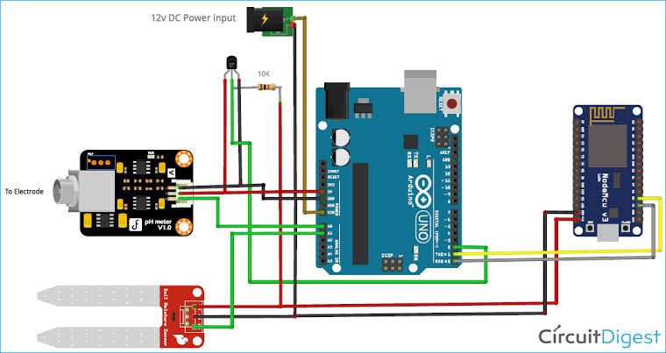
CIRCUITS DIAGRAM:
Smart water management system IoT application :
- Sensors: These can be flow meters, pressure sensors, and water quality sensors. They gather data about the state of the water system.
- Connectivity: IoT devices transmit data using wireless technologies like Wi-Fi, Bluetooth, or cellular networks to ensure seamless communication.
- Data Processing Unit: The collected data is sent to a central unit, where it is processed and analyzed. Machine learning algorithms may be employed for anomaly detection or predictive maintenance.
- Cloud Platform: The processed data is often stored and managed in the cloud, providing scalability and accessibility. Cloud platforms also facilitate remote monitoring and control.
- User Interface: A mobile or web application allows users to monitor their water consumption, receive alerts for leaks or unusual usage patterns, and control water-related devices remotely.
- Automation and Control: Based on the collected data and user preferences, the system can automate certain actions, such as shutting off water in case of a leak or optimizing irrigation schedules.
- Alerts and Notifications: Users receive real-time alerts about issues like leaks, abnormal water usage, or required maintenance.
- Integration with Other Systems: Integration with existing infrastructure and utilities can enhance the overall efficiency of water management.

